
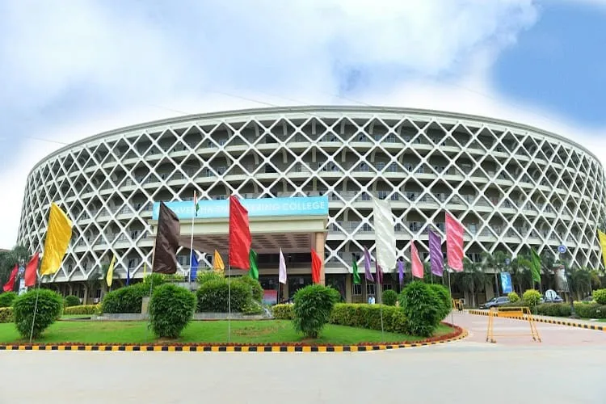
SAVEETHA SCHOOL OF ENGINEERING
Saveetha Institute of Medical and Technical Sciences (SIMATS), Chennai

COURSE ASSIGNMENT REPORT
Hostel Complaint Management System
A Cloud-Based Software-as-a-Service (SaaS) Application Built on Zoho Creator
Course: CSA1516 – Cloud Computing and Big Data Analytics
Topic 1 – Cloud-Based Hostel Complaint Management System

Submitted by
Vino Aldrin E
Register No.: 192511481
B.E. Computer Science and Engineering
Course Faculty / Guide: Dr. K. Santhiya Lakshmi
Academic Year: 2026 – 2027
Date of Submission: 02-Sep-2026

Assignment Information
Department | Computer Science and Engineering
Programme | B.E. – Computer Science and Engineering
Course Code & Course Name | CSA1516 – Cloud Computing and Big Data Analytics
Academic Year / Batch | 2026 – 2027
Faculty Name | Dr. K. Santhiya Lakshmi
Assignment Title | Cloud-Based Hostel Complaint Management System using Zoho Creator (SaaS)
Date of Issue | 25-Aug-2026
Date of Submission | 02-Sep-2026
Maximum Marks | 100
Course Outcome(s) – CO | CO5 – Apply cloud service models (IaaS / PaaS / SaaS) to design and deploy a cloud-based application for a real-world problem
Bloom's Taxonomy Level | Apply / Create (Level 3 – Level 6)
SDG Mapping (SDG 1–17) | SDG 9 – Industry, Innovation and Infrastructure; SDG 11 – Sustainable Cities and Communities
Industry / Societal Relevance | Digitises grievance redressal for hostel and campus facility management, reflecting real SaaS practices used in institutional service-desk systems

1. Problem Statement
Hostels in an educational institution receive a continuous stream of day-to-day maintenance complaints from resident students — electrical faults, plumbing leaks, room-maintenance issues, and cleanliness lapses. When such complaints are handled manually through registers or verbal reporting, they are difficult to track, easy to lose, and impossible to analyse for recurring patterns. There is no shared, real-time view of how many complaints are pending, which ones are being worked on, and which have been resolved.
This assignment requires the design and development of a simple cloud-based Hostel Complaint Management System using Zoho Creator, a low-code Platform/Software-as-a-Service (PaaS/SaaS) offering, to demonstrate the SaaS delivery model of cloud computing. The system must allow students to submit hostel-related complaints (electrical, plumbing, room maintenance, cleanliness) through an online form, store the complaints in the cloud, organise them by complaint type, priority and status, and provide a dashboard/report that tracks and analyses the number of complaints in each category.

2. Objective
The objective of this assignment is to apply the concepts of cloud computing — specifically the Software-as-a-Service (SaaS) model — to build a working, cloud-hosted application without provisioning or managing any physical or virtual infrastructure. Specifically, this work aims to:
- Understand and demonstrate the SaaS model of cloud computing through a hands-on, real-world application.
- Design and develop a cloud-based Hostel Complaint Management System entirely on the Zoho Creator low-code platform.
- Enable students to submit hostel-related complaints (electrical, plumbing, room maintenance and cleanliness) through an online form accessible from any browser.
- Store submitted complaints securely in the cloud and organise them by complaint type, priority and status.
- Provide a dashboard and report that track submitted complaints and analyse the number of complaints per category in real time.
- Evaluate the advantages and limitations of a low-code/SaaS approach compared with a traditionally coded, self-hosted system.

3. Requirements and Environment Used

3.1 Functional Requirements
- An online complaint-submission form capturing Student Name/ID, Hostel/Room Number, Complaint Type, Complaint Description, Date, and Priority.
- Automatic, cloud-based storage of every submitted complaint (no manual data entry into a separate system).
- Classification of complaints by Complaint Type (Electrical, Plumbing, Room Maintenance, Cleanliness), by Priority (High, Medium, Low) and by Status (Pending, In Progress, Resolved).
- A tabular report listing every complaint with all its fields.
- A dashboard summarising complaint counts by status, a pie chart of complaint-type distribution, and a priority-wise breakdown.
- A category-wise (Complaint Types) grouped view and a Calendar view organised by complaint date.

3.2 Non-Functional Requirements / Constraints
- Availability – the application must be reachable from any device with a browser and an internet connection, with no local installation.
- Usability – the complaint form must be simple enough for any student to fill without training.
- Scalability – the platform must be able to accommodate an increasing number of complaints and hostel blocks without redesign.
- Security – complaint data must be stored on secure, access-controlled cloud servers rather than on a local, unprotected file.
- Cost – the solution must not require the purchase or maintenance of dedicated servers (a key SaaS/PaaS constraint for this assignment).
- Time – the system had to be designed, built and tested within the assignment timeframe, which favoured a low-code approach over custom coding.

3.3 Environment and Tools Used
Category | Tool / Technology Used
Cloud Application Platform | Zoho Creator (Low-code PaaS used to build and deliver the app as SaaS)
Cloud Hosting / Storage | Zoho cloud data centres (application server + database managed entirely by Zoho)
Client / Access | Google Chrome web browser (desktop view); Zoho Creator also supports tablet and mobile layouts
Connectivity | Standard broadband / campus internet connection (HTTPS)
Sample Dataset | 10 sample complaint records for Noyyal Hostel, used to populate and test the application (see Section 6.3)
Documentation | Microsoft Word, screenshots captured directly from the deployed Zoho Creator application

4. Design / Proposed Solution
The proposed solution treats the Hostel Complaint Management System purely as an application built and consumed on top of a SaaS platform — no server, operating system, runtime or database was installed or configured manually. Zoho Creator was used to model the data, build the user-facing form, and auto-generate the report, dashboard, category and calendar views from the same underlying cloud dataset.

4.1 Three-Layer Architecture
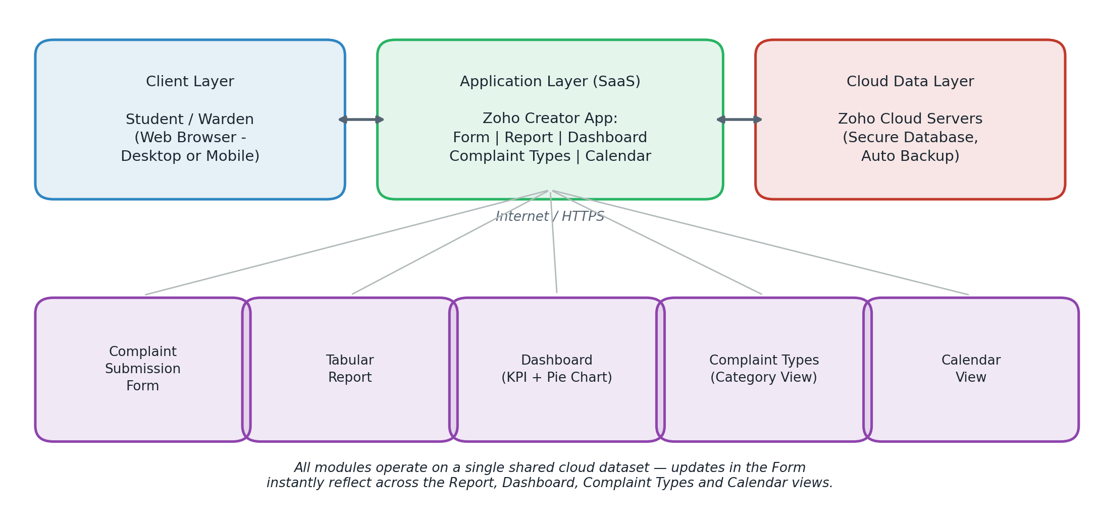
Fig. 4.1 — Three-layer SaaS architecture of the Hostel Complaint Management System
- Client Layer – any student or warden opens the application in a web browser (desktop or mobile); nothing is installed locally.
- Application Layer (SaaS) – the Zoho Creator app “Hostel_Complaint_Management_Zoho_Import” hosts the Form, Report, Dashboard, Complaint Types and Calendar modules.
- Cloud Data Layer – Zoho's cloud servers store every complaint record, handle backups, and are fully managed by the provider, which is the defining characteristic of the SaaS model.

4.2 Application Modules
Module | Purpose
Complaint Form | Captures a new complaint: Student ID, Student Name, Hostel Name, Room Number, Complaint Type, Complaint Description, Complaint Date, Priority, Status.
Report | A live, sortable tabular view of every complaint stored in the cloud, used for day-to-day tracking.
Dashboard | KPI cards for In-Progress / Resolved / Pending / Total counts, a pie chart of complaint-type distribution, and a priority-wise summary.
Complaint Types | A category-grouped (Kanban-style) view that clusters complaints under Plumbing, Cleanliness, Room Maintenance and Electrical.
Calendar | Displays complaints on the date they were raised, useful for spotting daily/weekly complaint load.

4.3 Data Fields
Field | Type | Notes
Student ID | Single Line | Unique identifier, e.g. 25CSE001
Student Name | Name | First name of the complainant
Hostel Name | Single Line | Defaults to “Noyyal Hostel” for this demonstration
Room Number | Single Line | e.g. A-203, B-105
Complaint Type | Dropdown | Electrical / Plumbing / Room Maintenance / Cleanliness
Complaint Description | Single Line | Free-text description of the issue
Complaint Date | Date (dd-MMM-yyyy) | Date the complaint was raised
Priority | Radio Button | High / Medium / Low
Status | Picklist | Pending / In Progress / Resolved

5. Algorithm / Pseudocode / Flowchart
Since the system is built on a low-code SaaS platform rather than hand-written server code, the “algorithm” takes the form of the workflow the platform executes whenever a complaint moves through the system. This is expressed below as pseudocode and as an equivalent flowchart.

5.1 Pseudocode – Complaint Lifecycle
BEGIN
Student opens Hostel Complaint Management App (SaaS, via browser)
Student ENTERS: StudentID, StudentName, HostelName, RoomNumber
Student SELECTS: ComplaintType {Electrical, Plumbing,
Cleanliness, RoomMaintenance}
Student ENTERS: ComplaintDescription, ComplaintDate
Student SELECTS: Priority {High, Medium, Low}
Student SUBMITS the form
IF all mandatory fields are valid THEN
System STORES the record in the cloud database
SET Status = "Pending"
ELSE
System DISPLAYS validation error, request is not saved
END IF
Warden / Admin OPENS Report / Dashboard / Complaint Types / Calendar
WHILE complaint is not resolved
IF work has started on the complaint THEN
UPDATE Status = "In Progress"
IF issue has been fixed THEN
UPDATE Status = "Resolved"
END WHILE
ON every INSERT or UPDATE:
Dashboard RECOMPUTES count of Pending, In Progress, Resolved
Dashboard REDRAWS pie chart of ComplaintType distribution
Dashboard RECOMPUTES Priority-wise totals (High / Medium / Low)
END

5.2 Flowchart
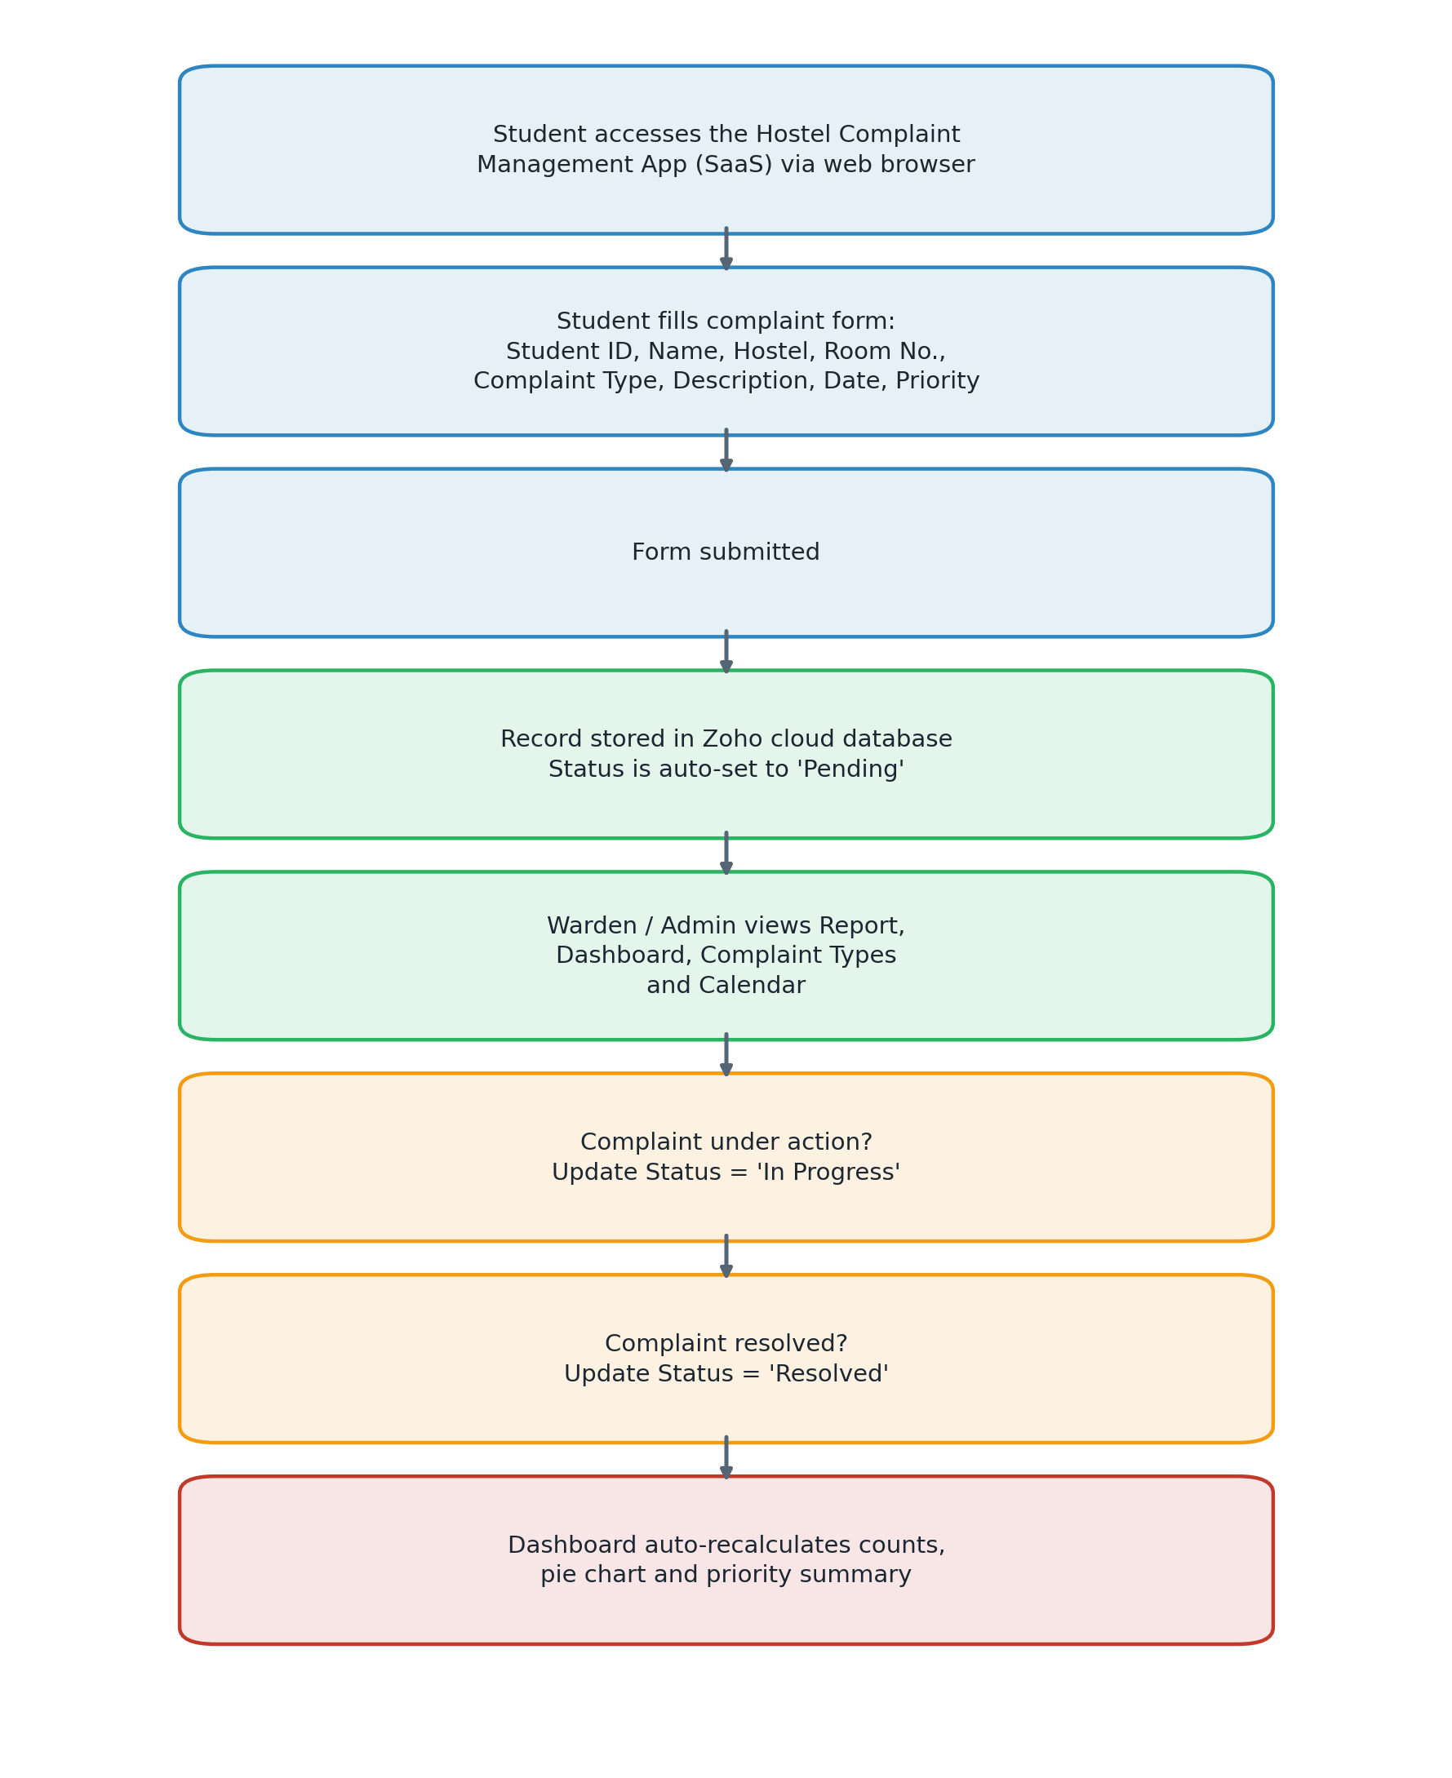
Fig. 5.1 — Flow of a complaint from submission to dashboard update

6. Implementation / Source Code
Zoho Creator is a low-code SaaS platform, so the “source code” of this project is expressed mainly as declarative application configuration (fields, forms, views and layouts) rather than hand-written server-side code. The implementation steps carried out are listed below, followed by the field configuration and the sample dataset used to populate and test the application.

6.1 Implementation Steps
- Created a new application named “Hostel_Complaint_Management_Zoho_Import” in the Zoho Creator workspace (SaaS account creatorapp.zoho.com/zoho_vino15/).
- Built the base form with the nine fields listed in Section 4.3, setting “Student ID” and “Complaint Type” as mandatory fields.
- Configured the “Complaint Type” field as a Dropdown with options Electrical, Plumbing, Room Maintenance and Cleanliness.
- Configured “Priority” as a Radio Button field with options High, Medium and Low, and “Status” as a Picklist with options Pending, In Progress and Resolved.
- Auto-generated the tabular Report view from the same form, which lists every stored complaint record.
- Built the Dashboard page using built-in widgets: count widgets for In Progress / Resolved / Pending / Total, and a pie chart widget bound to the “Complaint Type” field.
- Created the Complaint Types page as a category (Kanban-style) view, grouped by the “Complaint Type” field.
- Created the Calendar page, mapping each complaint to its “Complaint Date” field.
- Imported / entered 10 sample complaint records (see Section 6.3) to populate and test the application end-to-end.
- Published the application and verified that the Form, Report, Dashboard, Complaint Types and Calendar views all reflect the same live cloud dataset.

6.2 Field Configuration Logic (Deluge-equivalent Behaviour)
Zoho Creator's built-in field behaviour removes the need for most custom scripting for a form of this size. The platform natively performs the following, which would otherwise need to be hand-coded on a traditional (non-SaaS) stack:
- Mandatory-field validation on Student ID and Complaint Type before a record can be submitted.
- Automatic default value (“Noyyal Hostel”) pre-filled into the Hostel Name field.
- Automatic aggregation (COUNT/GROUP BY equivalent) for the Dashboard's status counts, pie chart and priority totals — recalculated instantly whenever a record is added, edited or deleted.
- Automatic view generation — the Report, Complaint Types and Calendar pages all stay in sync with the Form without any additional query being written.

6.3 Sample Dataset Used
The following 10 records (Noyyal Hostel) were used to build, populate and test the application end-to-end:
Student ID | Name | Room | Type | Description | Date | Priority
25CSE001 | Rahul Kumar | A-203 | Electrical | Ceiling fan not working | 02-Sep-2026 | High
25CSE002 | Priya S | A-204 | Plumbing | Water leakage near wash basin | 02-Sep-2026 | High
25CSE003 | Arun Kumar | B-105 | Cleanliness | Room cleaning has not been done | 01-Sep-2026 | Medium
25CSE004 | Divya R | B-210 | Room Maintenance | Door lock is damaged | 01-Sep-2026 | High
25CSE005 | Karthik M | C-112 | Electrical | Tube light is not working | 31-Aug-2026 | Low
25CSE006 | Sneha P | C-118 | Plumbing | Bathroom tap is leaking | 31-Aug-2026 | Medium
25CSE007 | Vignesh R | D-201 | Cleanliness | Dustbin has not been cleared | 30-Aug-2026 | Low
25CSE008 | Harini S | D-207 | Room Maintenance | Window handle is broken | 30-Aug-2026 | Medium
25CSE009 | Ajay K | E-102 | Electrical | Power socket is loose | 29-Aug-2026 | High
25CSE010 | Meena V | E-115 | Cleanliness | Common area requires cleaning | 29-Aug-2026 | Medium

7. Test Cases and Expected / Actual Results
The application was tested manually by exercising the Form, Report, Dashboard, Complaint Types and Calendar views after populating the 10-record sample dataset. All test cases produced the expected results, confirming that the SaaS application behaves consistently end-to-end.
ID | Test Description | Expected Result | Actual Result | Status
TC01 | Submit a complaint with all fields filled correctly | Record is saved and appears in the Report | Record 25CSE001 saved and visible in Report | Pass
TC02 | Submit the form leaving a mandatory field (Student ID) blank | Form blocks submission with a validation message | Submission blocked until Student ID was entered | Pass
TC03 | Open Dashboard after all 10 records are added | Counts show Total = 10, Pending = 4, In Progress = 3, Resolved = 3 | Dashboard displayed Total 10, Pending 4, In Progress 3, Resolved 3 | Pass
TC04 | Check Priority split on Dashboard | High = 4, Medium = 4, Low = 2 | Dashboard displayed High 4, Medium 4, Low 2 | Pass
TC05 | Open Complaint Types page and check grouping | Records grouped correctly: Plumbing 2, Cleanliness 3, Room Maintenance 2, Electrical 3 | All 10 records grouped correctly under the four categories | Pass
TC06 | Open Calendar and check complaints appear on their Complaint Date | Each complaint appears under its correct date in September/August 2026 | All records appeared under the correct dates on the Calendar | Pass
TC07 | Update a record's Status from Pending to In Progress | Dashboard counts update automatically without a manual refresh of any other page | Dashboard counts updated instantly across Report and Dashboard | Pass
TC08 | Access the application from a different device/browser session | Same live data is visible — confirms cloud (not local) storage | Identical data visible, confirming SaaS/cloud storage | Pass

8. Execution Screenshots / Output
The following screenshots were captured directly from the deployed, live Zoho Creator application, confirming that it is genuinely hosted and running in the cloud (note the application URL in the browser's address bar in each figure).
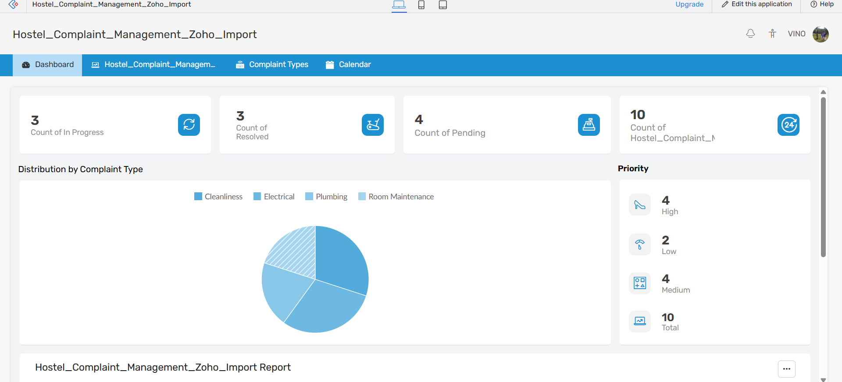
Fig. 8.1 — Dashboard: status KPI cards, complaint-type pie chart, and priority summary
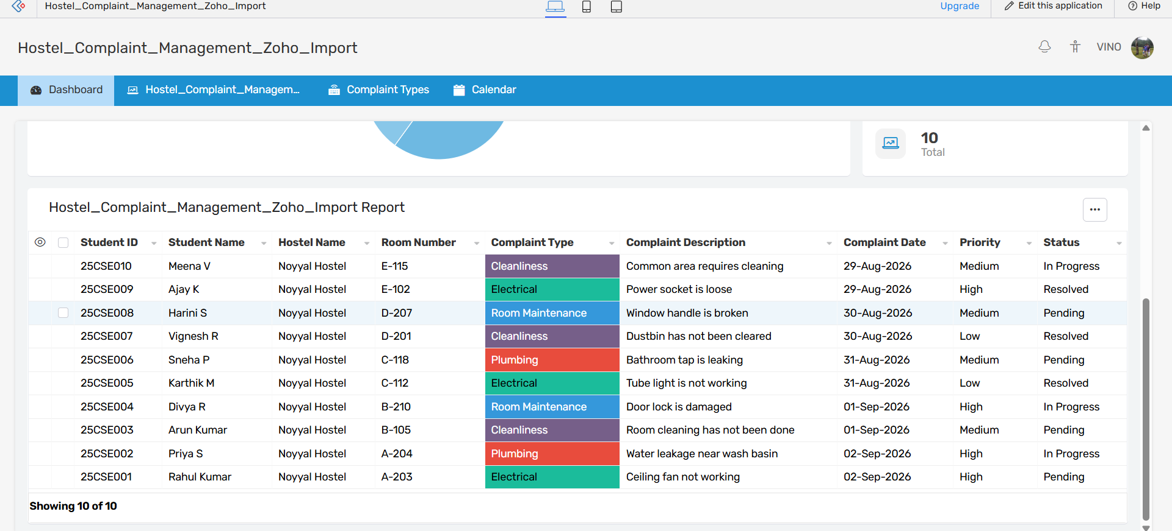
Fig. 8.2 — Dashboard (scrolled): embedded tabular report of all complaints

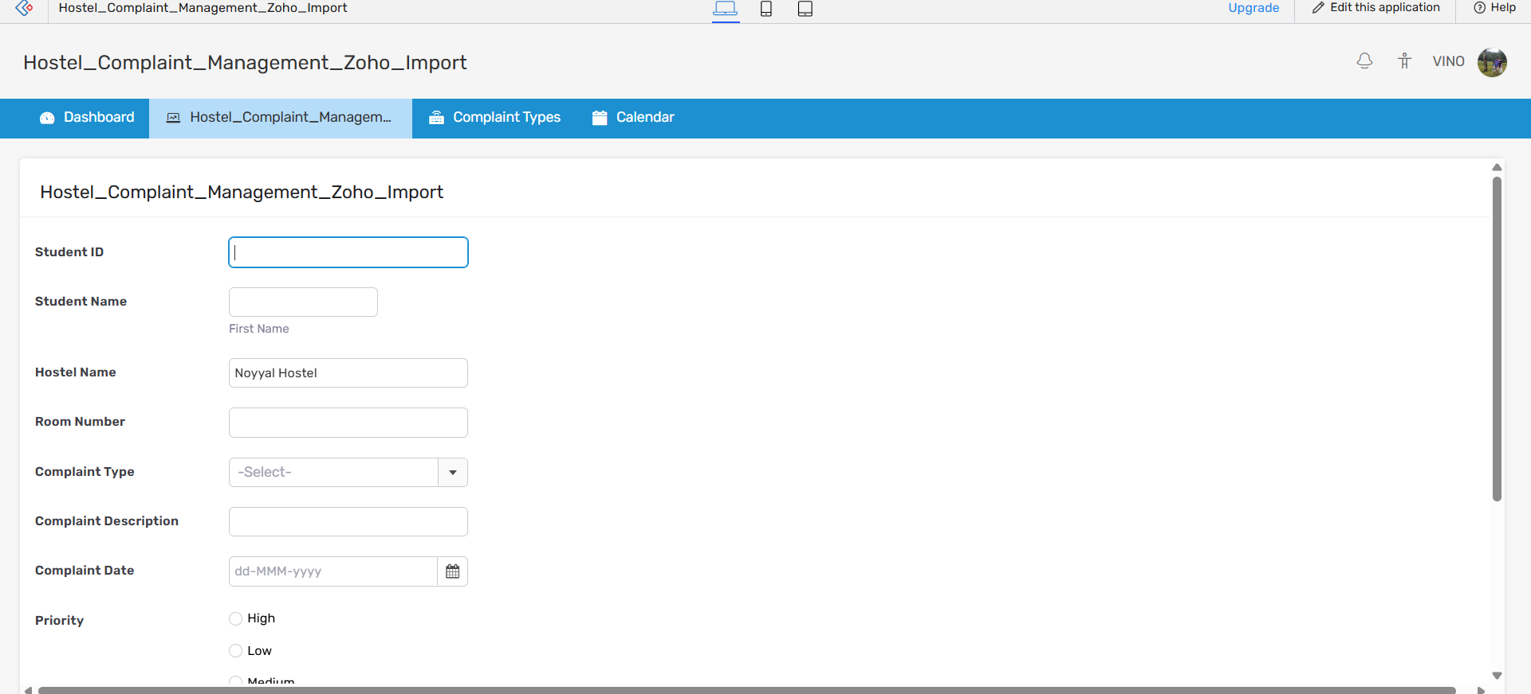
Fig. 8.3 — Complaint submission form used by students to raise a new complaint
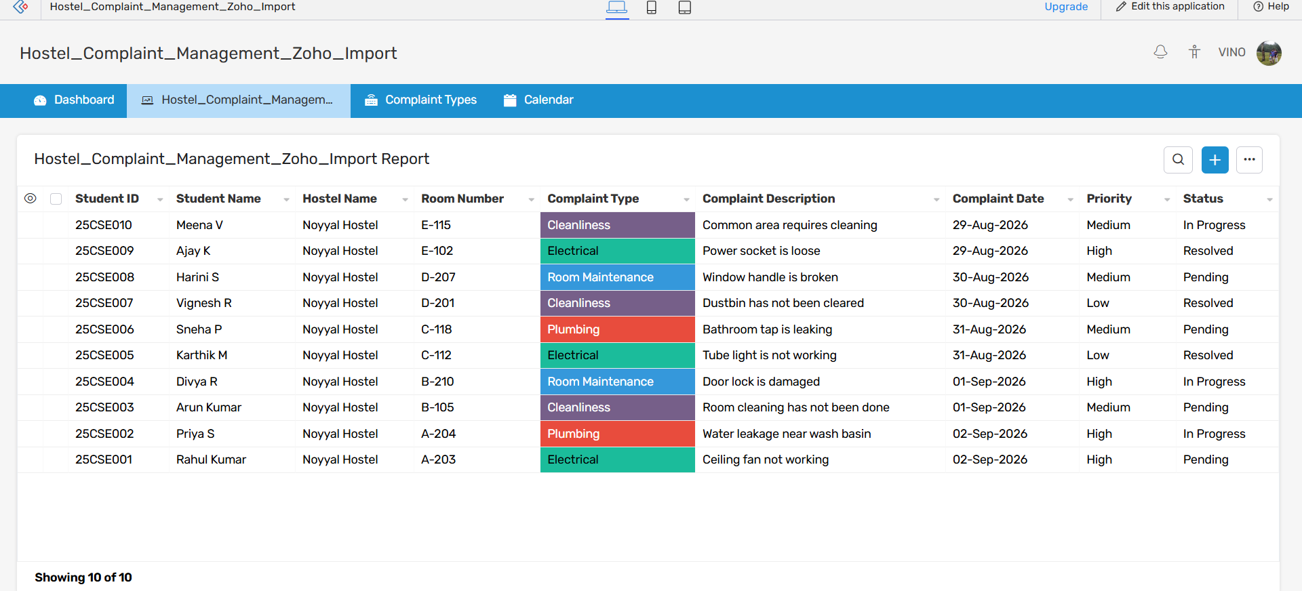
Fig. 8.4 — Full report view showing all 10 stored complaint records

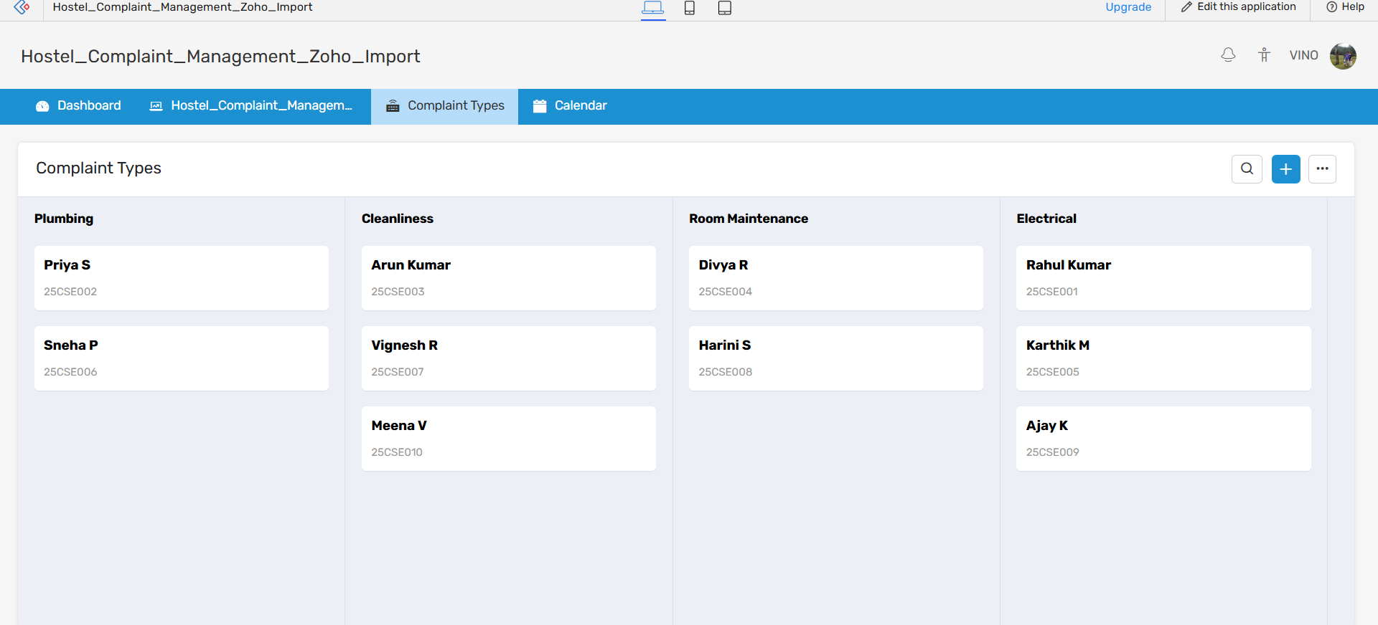
Fig. 8.5 — Complaint Types view: complaints grouped by category (Plumbing, Cleanliness, Room Maintenance, Electrical)
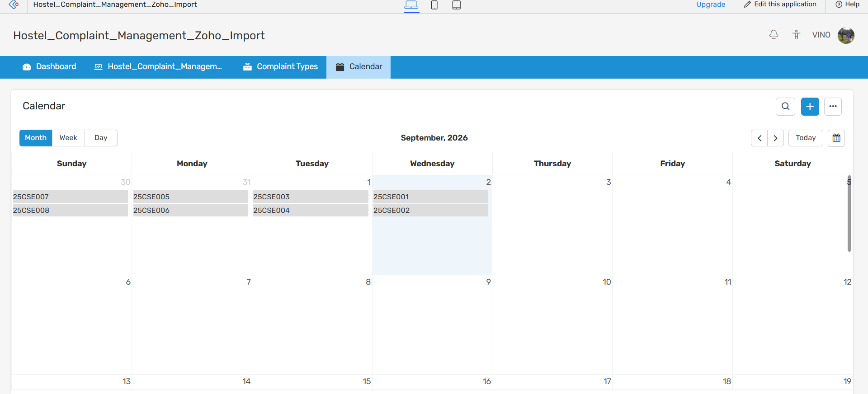
Fig. 8.6 — Calendar view: complaints organised by the date they were raised

9. Analysis and Discussion

9.1 Interpreting the Dashboard Data
Across the 10 sample complaints raised for Noyyal Hostel, the dashboard computed the following breakdown automatically, without any manual counting:
- Status: 4 Pending (40%), 3 In Progress (30%), 3 Resolved (30%) — out of 10 total complaints.
- Priority: 4 High, 4 Medium, 2 Low — showing that 40% of open issues (electrical faults, water leakage, damaged locks) were flagged as urgent.
- Complaint Type: Electrical and Cleanliness each account for 3 complaints, Plumbing and Room Maintenance 2 each — indicating electrical and cleanliness issues are the most frequently reported categories in this sample and would be the first areas a hostel administration should prioritise for preventive maintenance.
Because these figures are computed live from the underlying cloud dataset, any new complaint immediately shifts the pie chart and KPI cards — this is a direct, observable benefit of the SaaS approach over a manually maintained register or spreadsheet, where such recalculation would need to be done by hand.

9.2 Why a SaaS / Low-Code Approach Was Chosen
Three broad approaches were considered before settling on Zoho Creator:
- Custom-coded web application (e.g., PHP/MySQL or a MERN stack) — offers full control over logic and UI, but requires provisioning a server (IaaS/PaaS), writing and testing form-handling, database and reporting code, and maintaining security patches — far beyond the scope and time available for this assignment.
- Spreadsheet-based tool (Google Forms + Google Sheets) — quick to set up and free, but lacks a built-in dashboard, category-grouped view and calendar out of the box; charts and status tracking would need to be built manually.
- Low-code SaaS platform (Zoho Creator) — chosen for this assignment because it directly demonstrates the SaaS delivery model: the provider manages the servers, database, security and uptime, while the developer focuses only on the application's data model and views. It also natively supplies the dashboard, report, category and calendar views the problem statement asks for, with no separate charting library or backend code required.

9.3 Advantages Observed
- On-demand self-service — the application was created and published without raising any IT infrastructure request or provisioning a server.
- Broad network access — the same live data was verified to be accessible from different browser sessions/devices (TC08), consistent with the SaaS characteristic of ubiquitous access.
- Rapid elasticity — adding new fields, views or sample records required no re-deployment step; the platform absorbed the changes instantly.
- Reduced development time — the entire form, report, dashboard, category view and calendar were built and tested well within the assignment timeframe, which would be difficult with a hand-coded solution.

9.4 Limitations and Trade-offs
- Customisation ceiling — highly specific UI/UX requirements or complex business logic would eventually need Zoho's Deluge scripting or a custom-coded platform; the low-code approach trades some flexibility for speed.
- Platform / vendor dependency — the application's availability and future pricing depend entirely on Zoho as the SaaS vendor (a form of vendor lock-in inherent to SaaS).
- Connectivity dependency — without internet access, students cannot submit or view complaints, unlike a purely offline register.
- Free/trial-tier limits — the number of users, records or storage on a free Zoho Creator plan is capped, which would need a paid subscription for real hostel-wide deployment.

9.5 Broader Considerations
- Sustainability / Environment — replacing a paper complaint register with a cloud form reduces paper usage and physical storage.
- Accessibility — any student with a browser and internet connection, on any device, can raise or check a complaint, improving accessibility over a register kept at a single physical desk.
- Data security / privacy — complaint data (including student identifiers) resides on Zoho's access-controlled, encrypted cloud infrastructure rather than an unprotected paper register or shared spreadsheet.
- Societal / industry relevance — the same pattern (a low-code SaaS form + dashboard) is used by real facility-management and IT service-desk systems, aligning this assignment with SDG 9 (Industry, Innovation and Infrastructure) and SDG 11 (Sustainable Cities and Communities) by supporting smarter, more responsive campus infrastructure.

10. Conclusion
This assignment successfully designed and implemented a cloud-based Hostel Complaint Management System entirely on the Zoho Creator SaaS platform, meeting every requirement in the problem statement. Students can raise electrical, plumbing, room-maintenance and cleanliness complaints through a simple online form; every complaint is stored in the cloud and automatically organised by complaint type, priority and status; and a live dashboard, report, category view and calendar together provide a simple, effective way to track and analyse complaints without any manual tallying.
Testing with a 10-record sample dataset (Section 6.3 and Section 7) confirmed that the Form, Report, Dashboard, Complaint Types and Calendar views all remain synchronised in real time, and that the platform correctly enforces mandatory-field validation. The exercise concretely demonstrated the core characteristics of the SaaS model — on-demand self-service, broad network access, and a fully provider-managed backend — while also surfacing realistic trade-offs such as reduced customisation and dependency on the SaaS vendor.
Within the scope of this assignment, the system meets its stated requirements; the limitations identified in Section 9.4, and the enhancements discussed in Section 11, outline a clear path for extending it into a production-ready hostel-management tool.

11. Student Reflection
Working on this assignment gave me a much more concrete understanding of cloud computing than reading about it in theory. Building the Hostel Complaint Management System on Zoho Creator showed me, hands-on, what it actually means for an application to be delivered as a Software-as-a-Service: I never had to think about servers, operating systems or databases — I only had to design the fields, the form and the views, and the platform took care of storage, availability and computation. This made the difference between SaaS and traditional, self-hosted software very tangible rather than just a definition to memorise.
I also learned how a single underlying dataset can power multiple views — a form, a report, a dashboard with charts, a category-grouped board and a calendar — without writing separate code for each one, and how quickly a working, testable cloud application can be produced this way. Designing the dashboard also made me think about which numbers actually matter to someone managing a hostel — status counts, priority split and category distribution — rather than just displaying raw data.
If I had more time and resources, I would extend the system with automatic email/SMS notifications to students when their complaint status changes, role-based logins so wardens and students see different views, a complaint-escalation rule for issues left “Pending” beyond a set number of days, the ability to upload a photo of the issue at submission time, and a short feedback/rating step once a complaint is marked Resolved. Together these would move the project from a working demonstration of the SaaS model to something closer to a system a real hostel could depend on day to day.

12. Individual Contribution of Group Members
This is an individual assignment completed independently by the student named below.
Name | Register No. | Contribution
Vino Aldrin E | 192511481 | Problem analysis, application design (data model, architecture and module design), complete implementation on Zoho Creator (form, report, dashboard, complaint-type and calendar views), sample-data population, end-to-end testing, and preparation of this report.

13. References
All AI-assisted drafting tools, datasets and third-party platforms used in this assignment are acknowledged below, along with recent (2023–2026) sources consulted for background on the SaaS model, cloud computing and low-code development.
[1] Zoho Corporation, “Zoho Adds Advanced AI Capabilities to Low-Code Development Platform, Zoho Creator,” BusinessWire, Apr. 2025. https://www.businesswire.com/news/home/20250430079224/en/Zoho-Adds-Advanced-AI-Capabilities-to-Low-Code-Development-Platform-Zoho-Creator-Enabling-Faster-Easier-Business-App-Creation
[2] Zoho Corporation, “Best Low-code App Creation Platform – Zoho Creator,” zoho.com/creator, 2025. https://www.zoho.com/creator/low-code-platform.html
[3] “Adoption of low-code and no-code development: A systematic literature review and future research agenda,” ScienceDirect (Information and Software Technology), 2024. https://www.sciencedirect.com/science/article/abs/pii/S0164121224003443
[4] Amazon Web Services, “What is SaaS? – Software as a Service Explained,” aws.amazon.com, 2026. https://aws.amazon.com/what-is/saas/
[5] IBM, “What is software as a service (SaaS)?,” IBM Think, ibm.com/think/topics/saas, 2024. https://ibm.com/think/topics/saas
[6] GII Research, “Complaint Management Software Market by Deployment, Industry – Global Forecast 2025–2030,” 2025. https://www.giiresearch.com/report/ires1587342-complaint-management-software-market-by-deployment.html
[7] App Builder, “Low-Code Statistics And Trends 2025,” appbuilder.dev, 2025. https://www.appbuilder.dev/low-code-statistics/

